1. How many trips have been recorded total during the chosen period?

With the combined data for (2014-2018):

SUM(Trips taken over the past YEAR) = **67,014,834 trips taken**

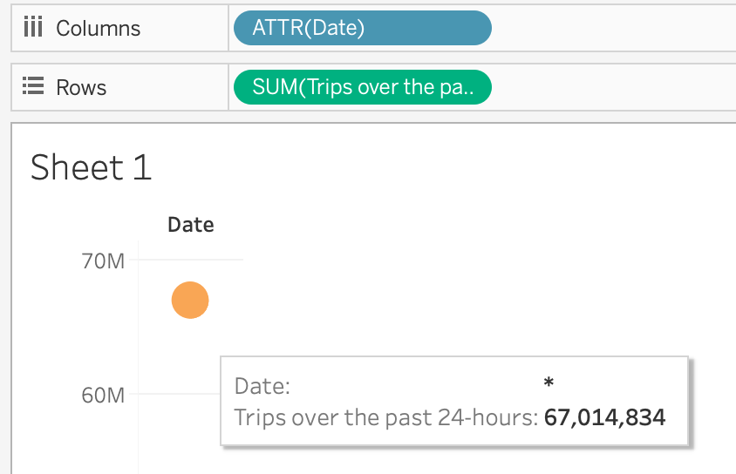

Figure 1.

Ridership (Total Trips) per YEAR (2014-2018)

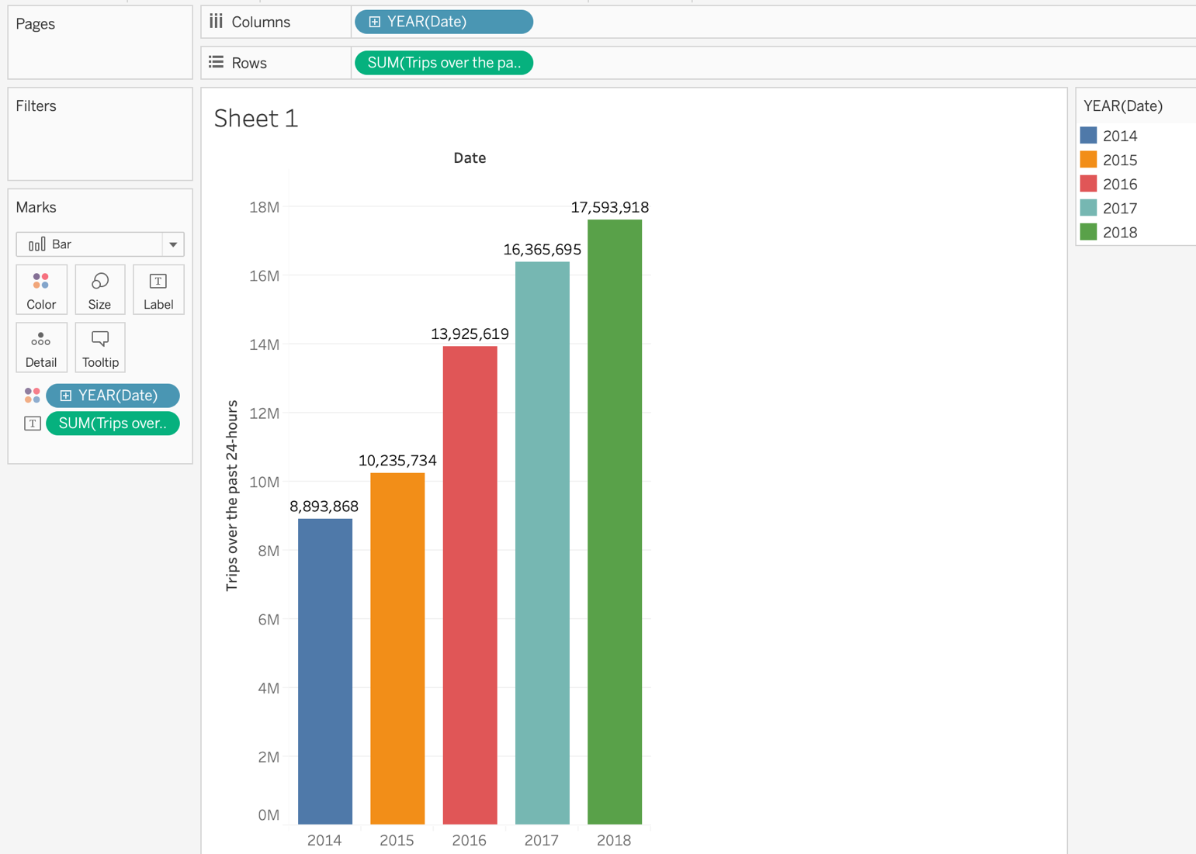

2. By what percentage has total ridership changed?

Year-over-Year Percentage Change (2014-2018)

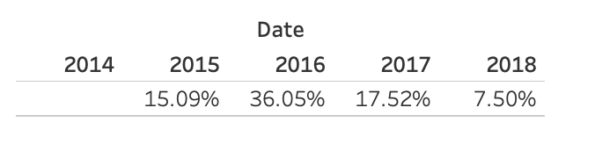

3. How has the proportion of short-term customers and annual subscribers changed (2014-2018)?

**We clearly see that Most of the Annual Purchases are made during colder months, while**

**Most of the 24-Hour Passes are purchased during the warm months.**

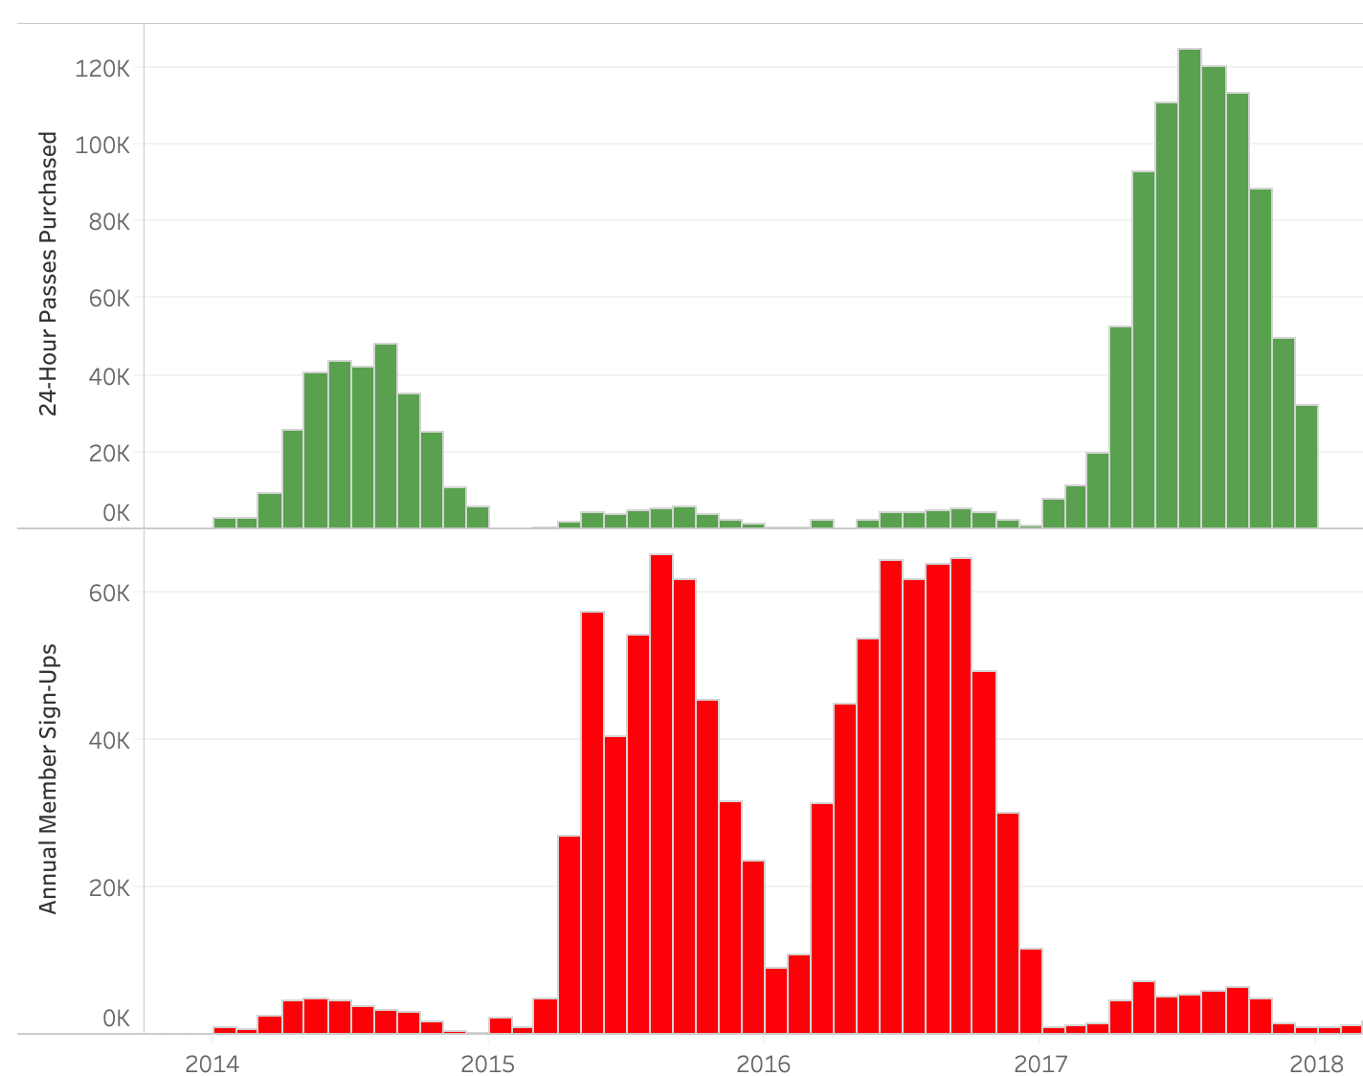

4. What are the peak hours in which bikes are used during summer months?

(For this, data is taken from June-August of 2018)

**The Busiest Hours are 8AM, 5PM-7PM**

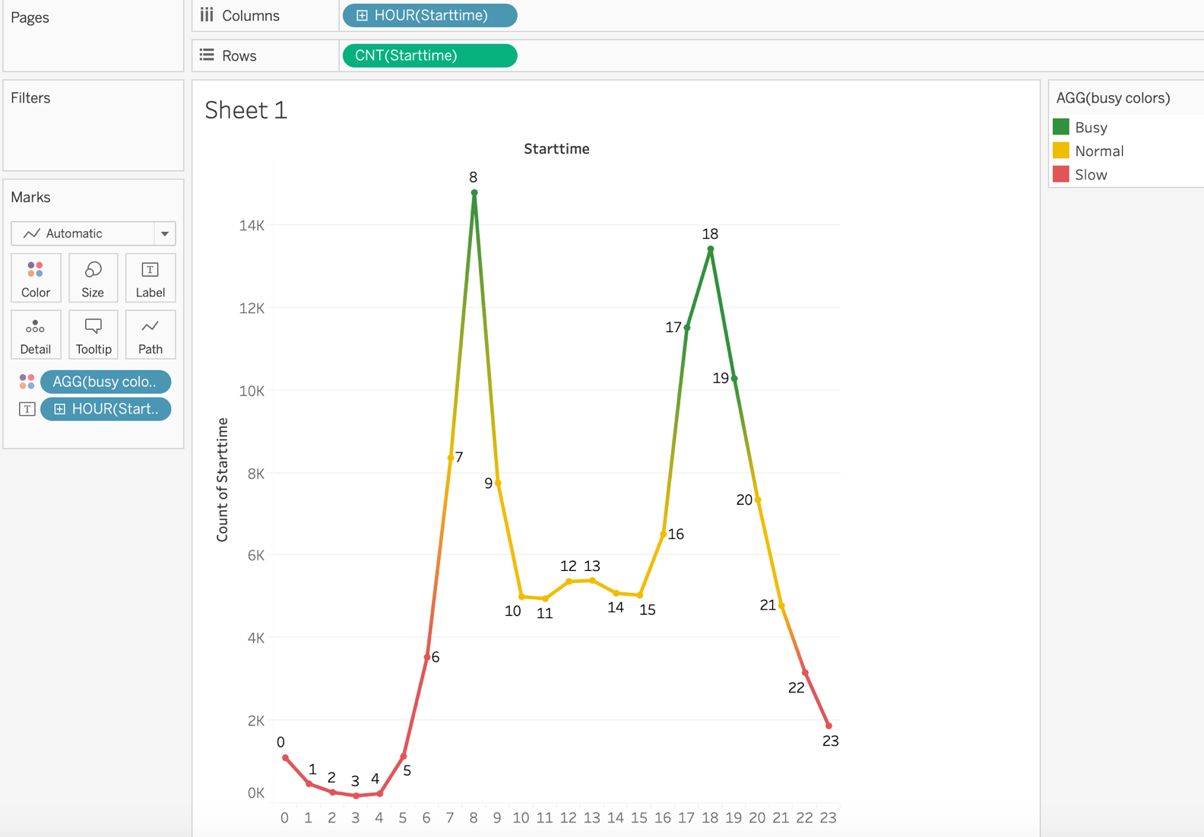

5. What are the peak hours in which bikes are used during winter months?

(For this, data is taken from December 2018 -February 2019)

**The Busiest Hours are 8AM, 5PM-6PM**

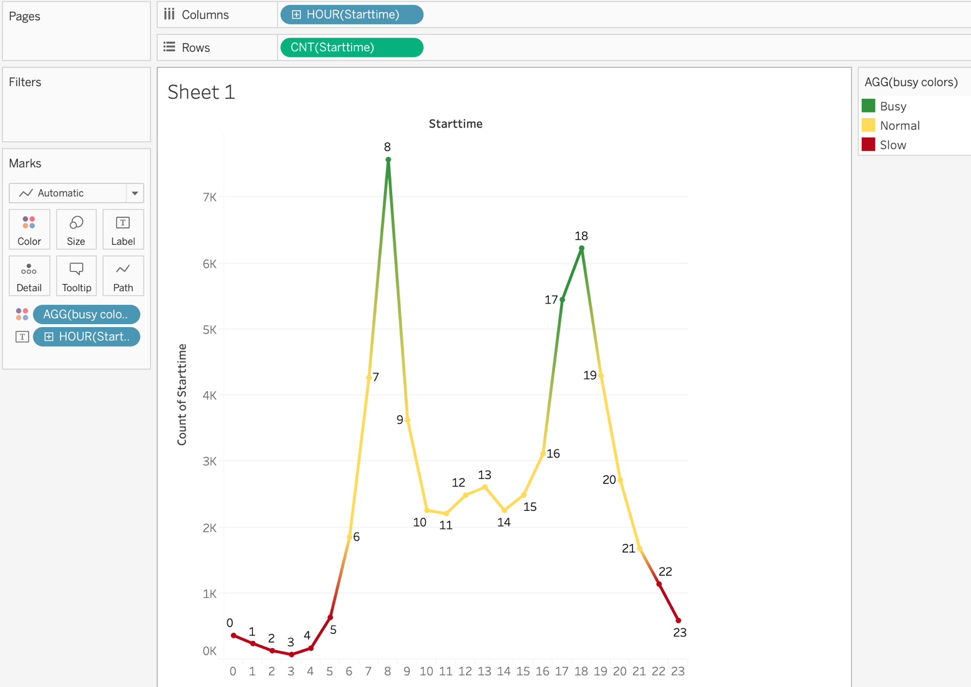

6. Today ( June 2019 ), what are the top 10 stations in the city for starting a journey? (Based on data, why do you hypothesize these are the top locations?)

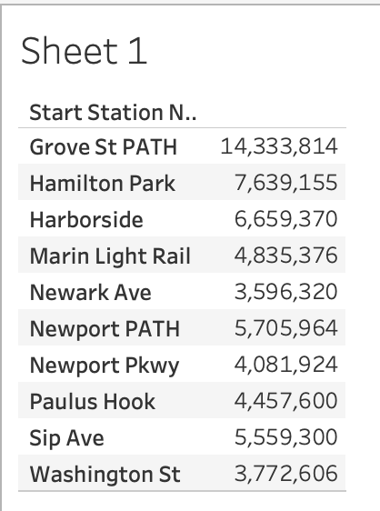

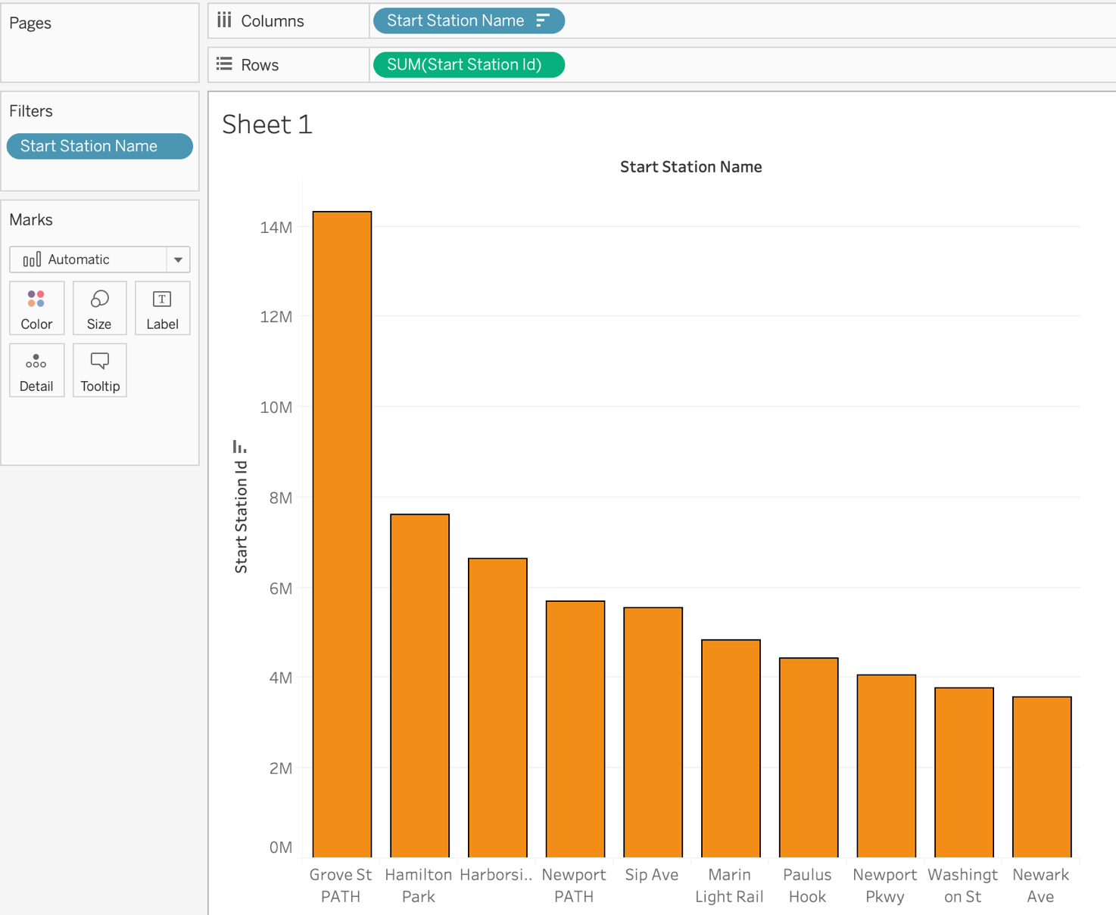

(Based on data, why do you hypothesize these are the top locations?)

**The Top Ten Start Stations are mostly concentrated on the East Side**

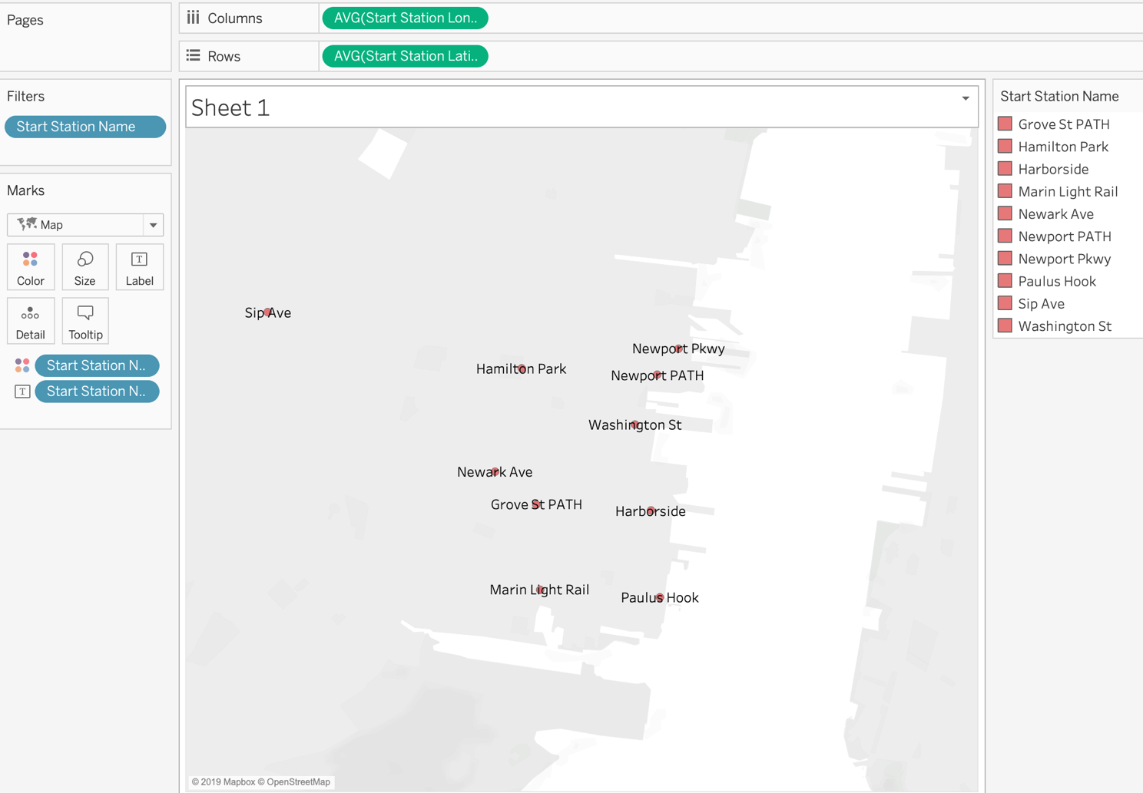

7. Today ( June 2019 ), what are the top 10 stations in the city for ending a journey?

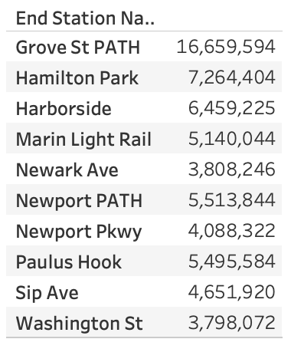

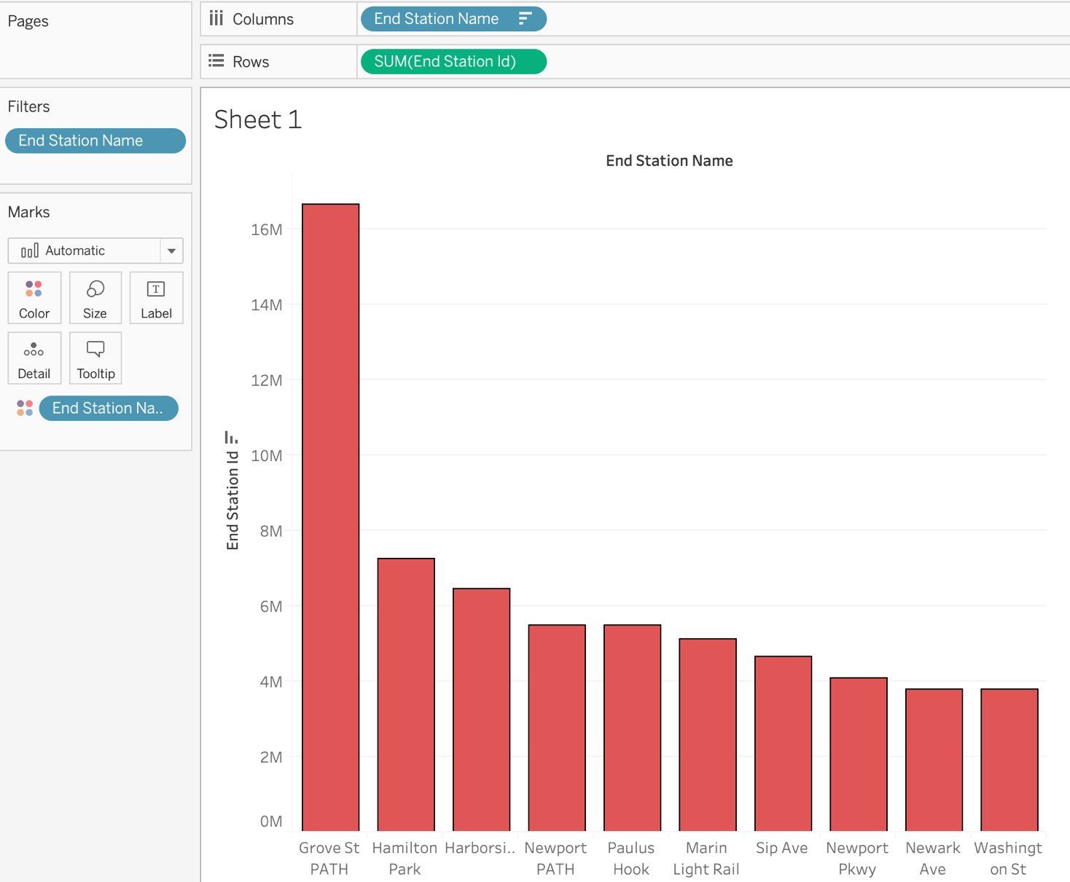

(Based on data, why?)

**The Top Ten Ending Stations are exactly the same list as the Top Ten Starting Stations, which are mostly all on the east side of New York City.**

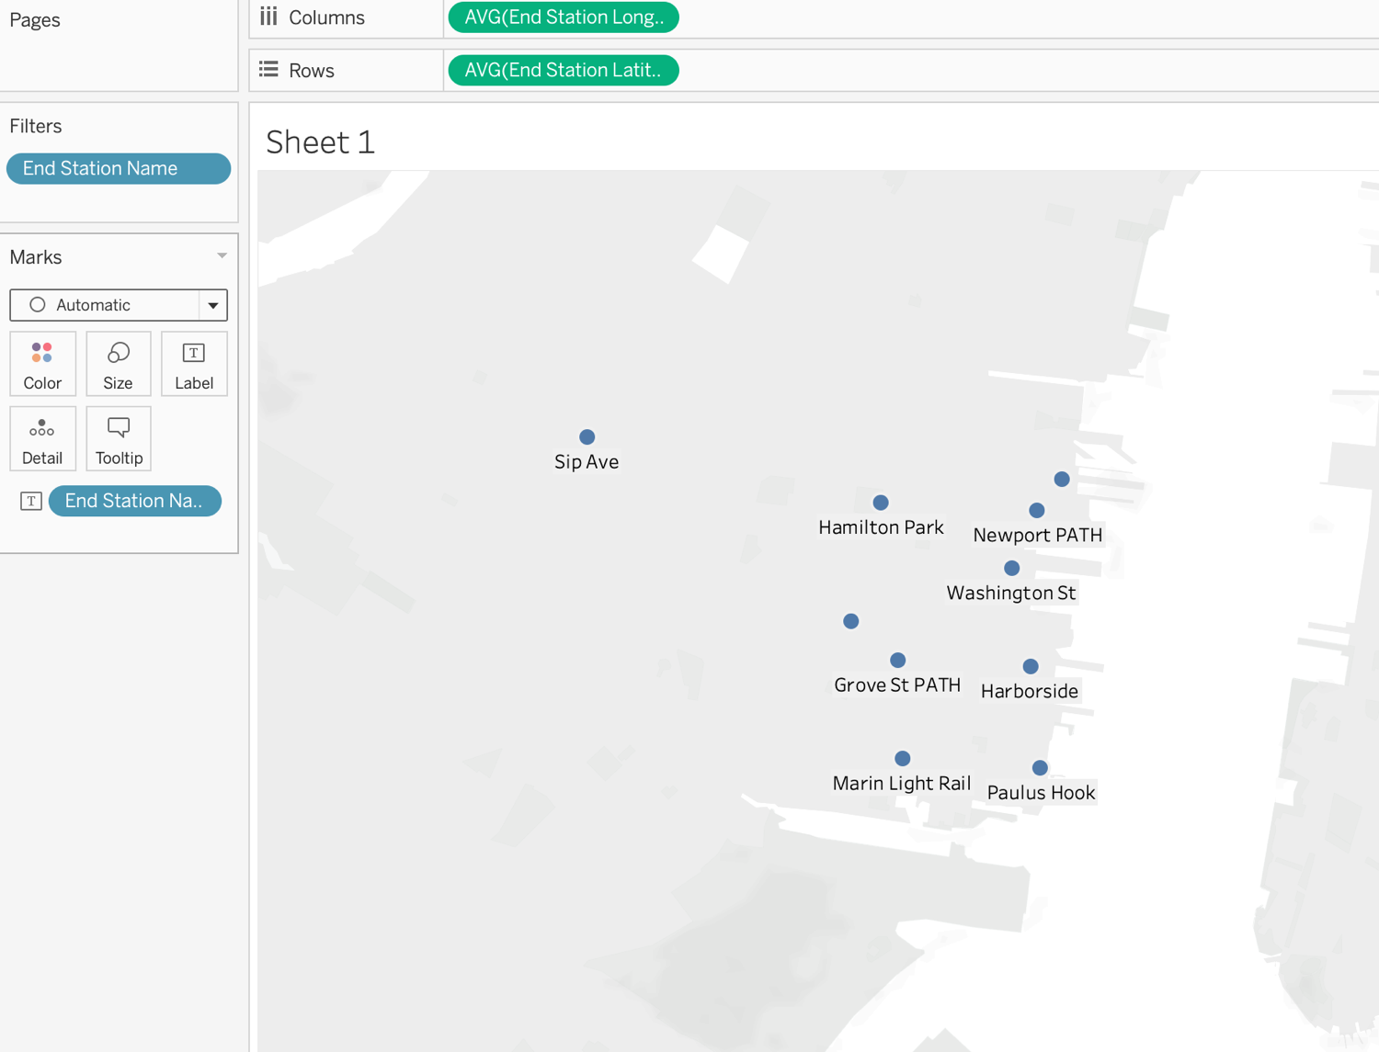

8. Today ( June 2019 ), what are the bottom 10 stations in the city for starting a journey?

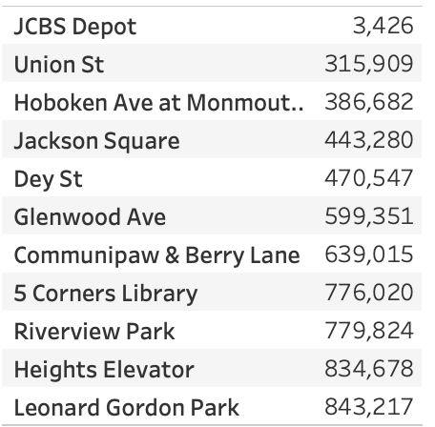

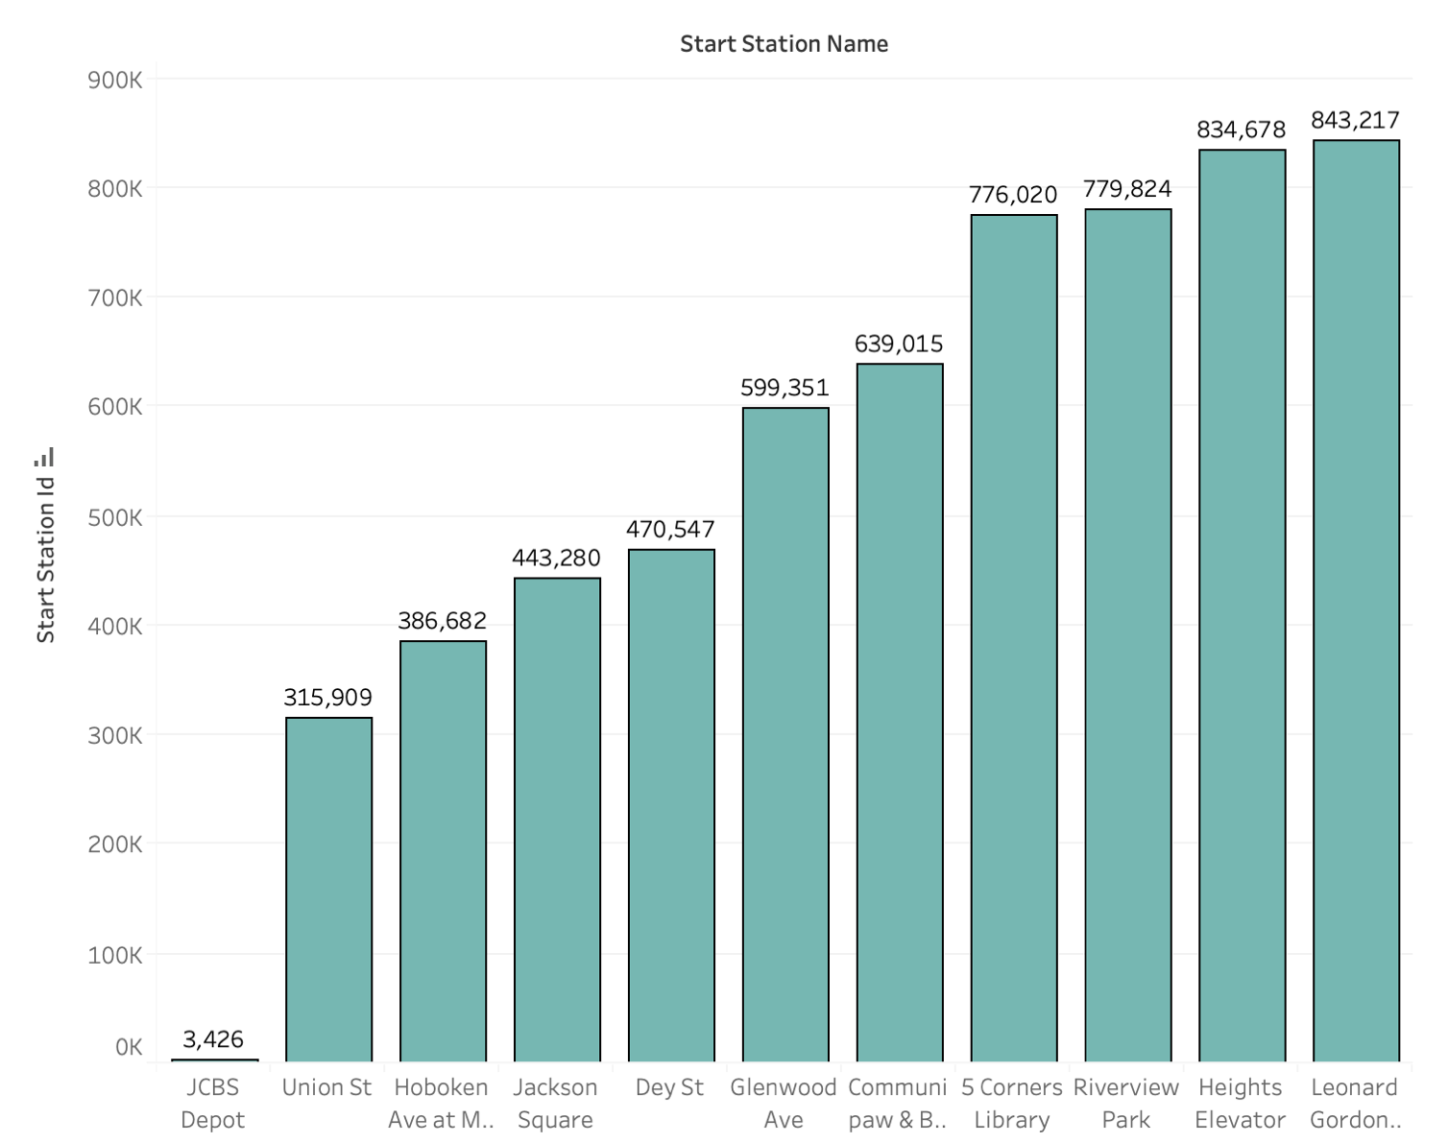

(Based on data, why?)

**The Bottom Ten Starting Stations are all in the middle of the city.**

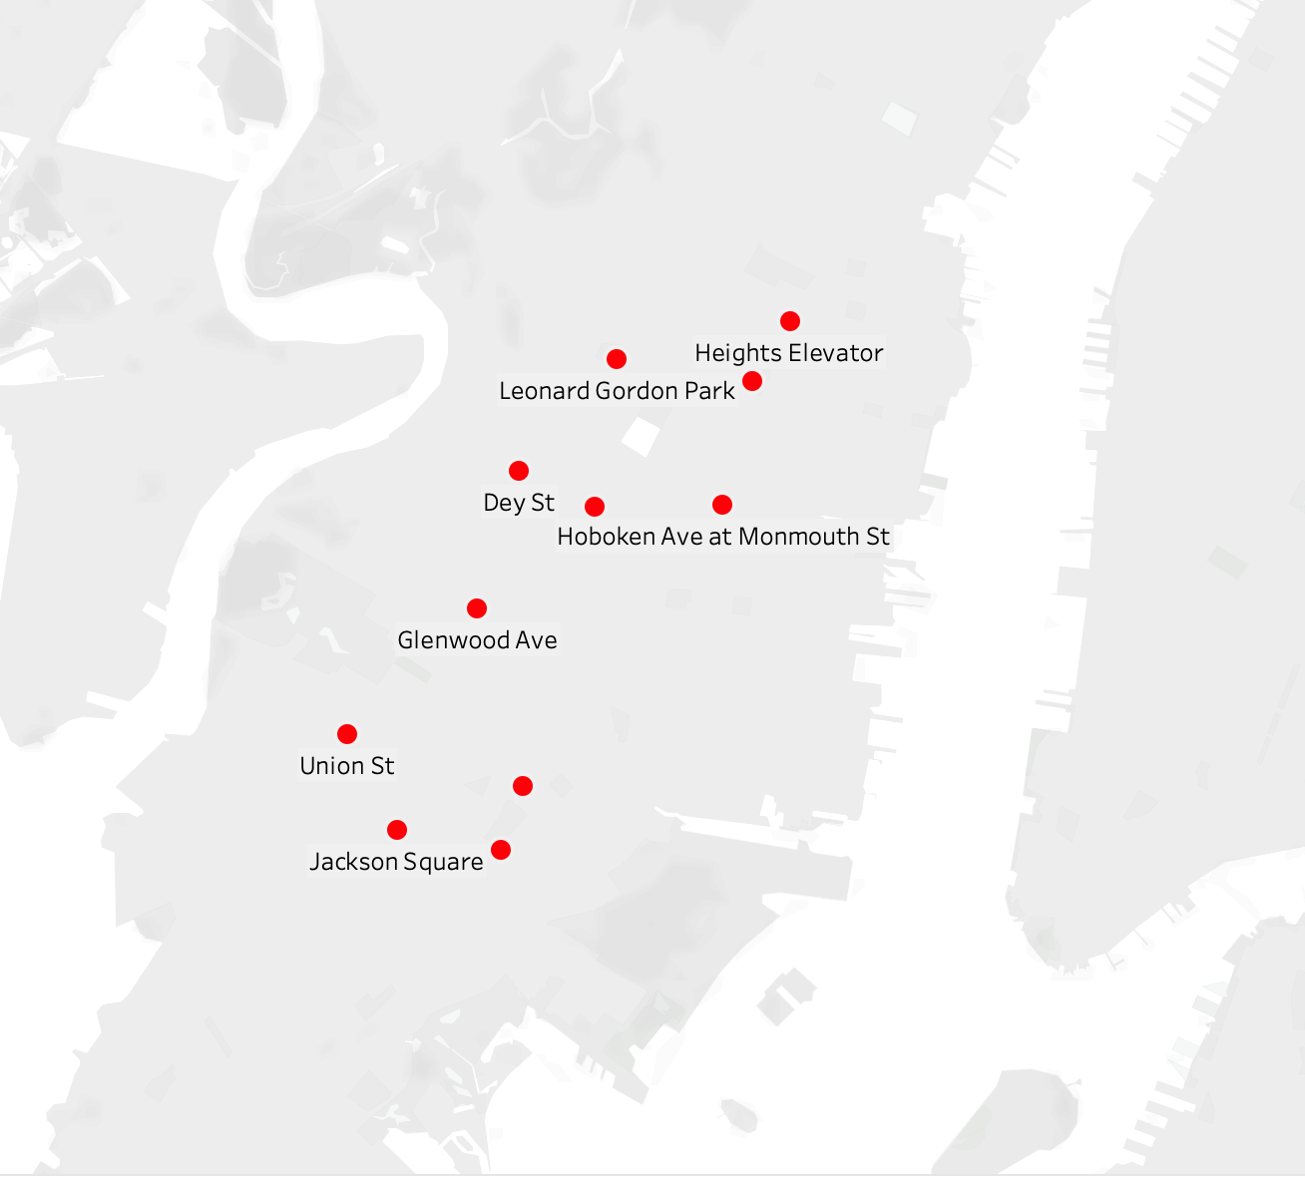

9. Today( June 2019 ), what are the bottom 10 stations in the city for ending a journey (Based on data, why?)

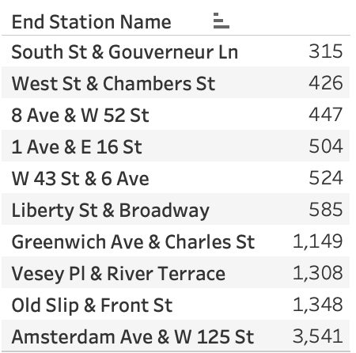

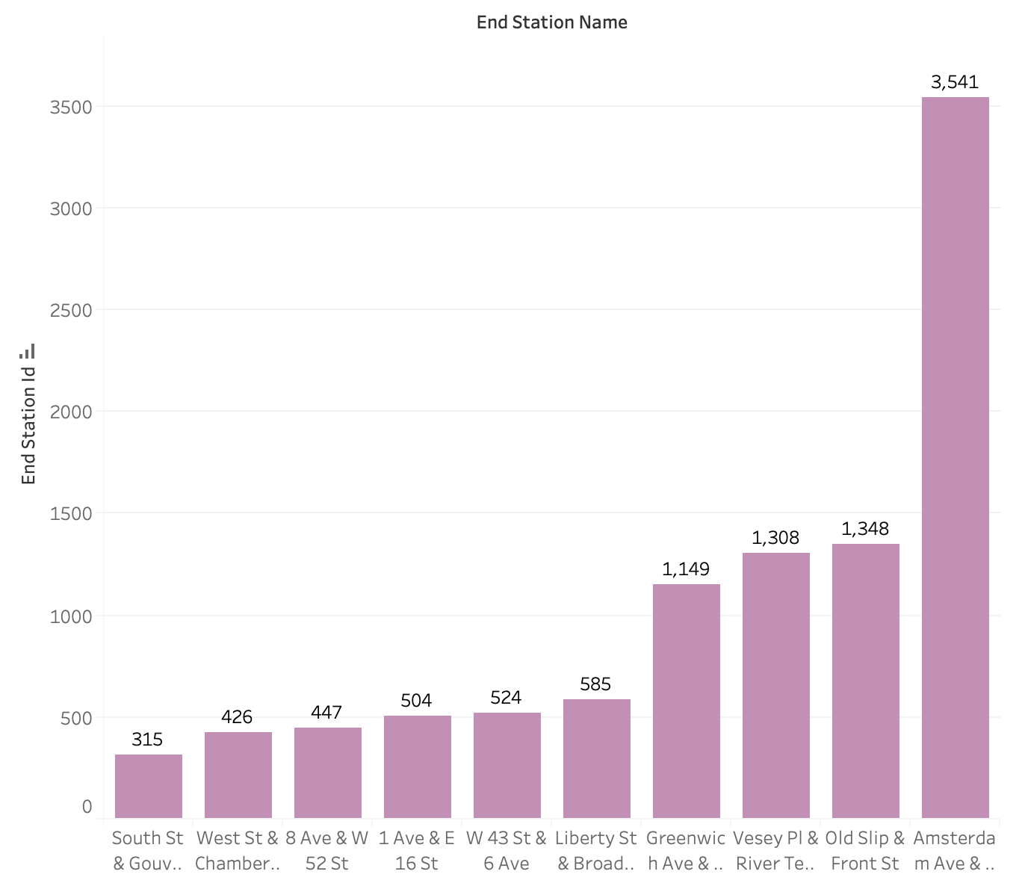

(Based on data, why?)

**The Bottom Ten Ending Stations are all across the River.**

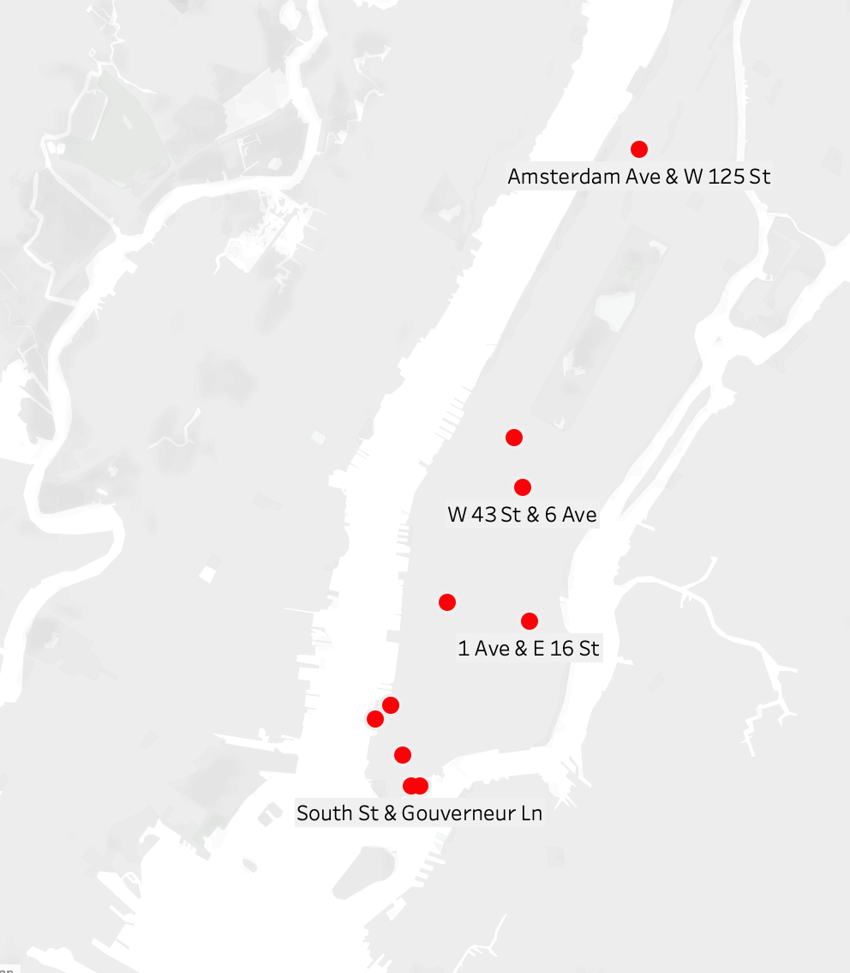

10. Today (June 2019), what is the gender breakdown of active participants (Male v. Female)?

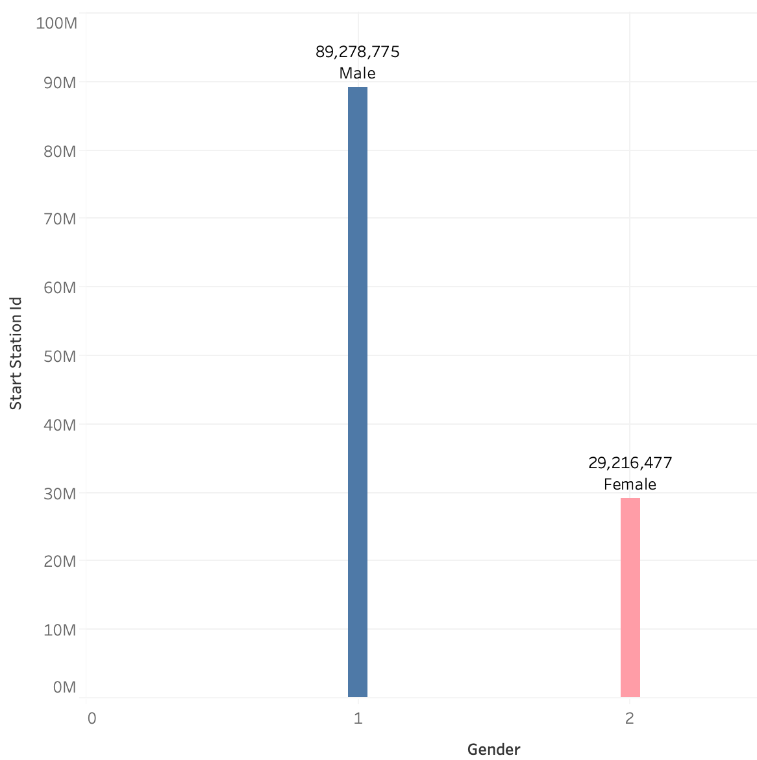

11. How effective has gender outreach been in increasing female ridership over the timespan (June 2019)?

**The Men’s’ ridership portion continues to grow faster than the Women’s’ Portion.**

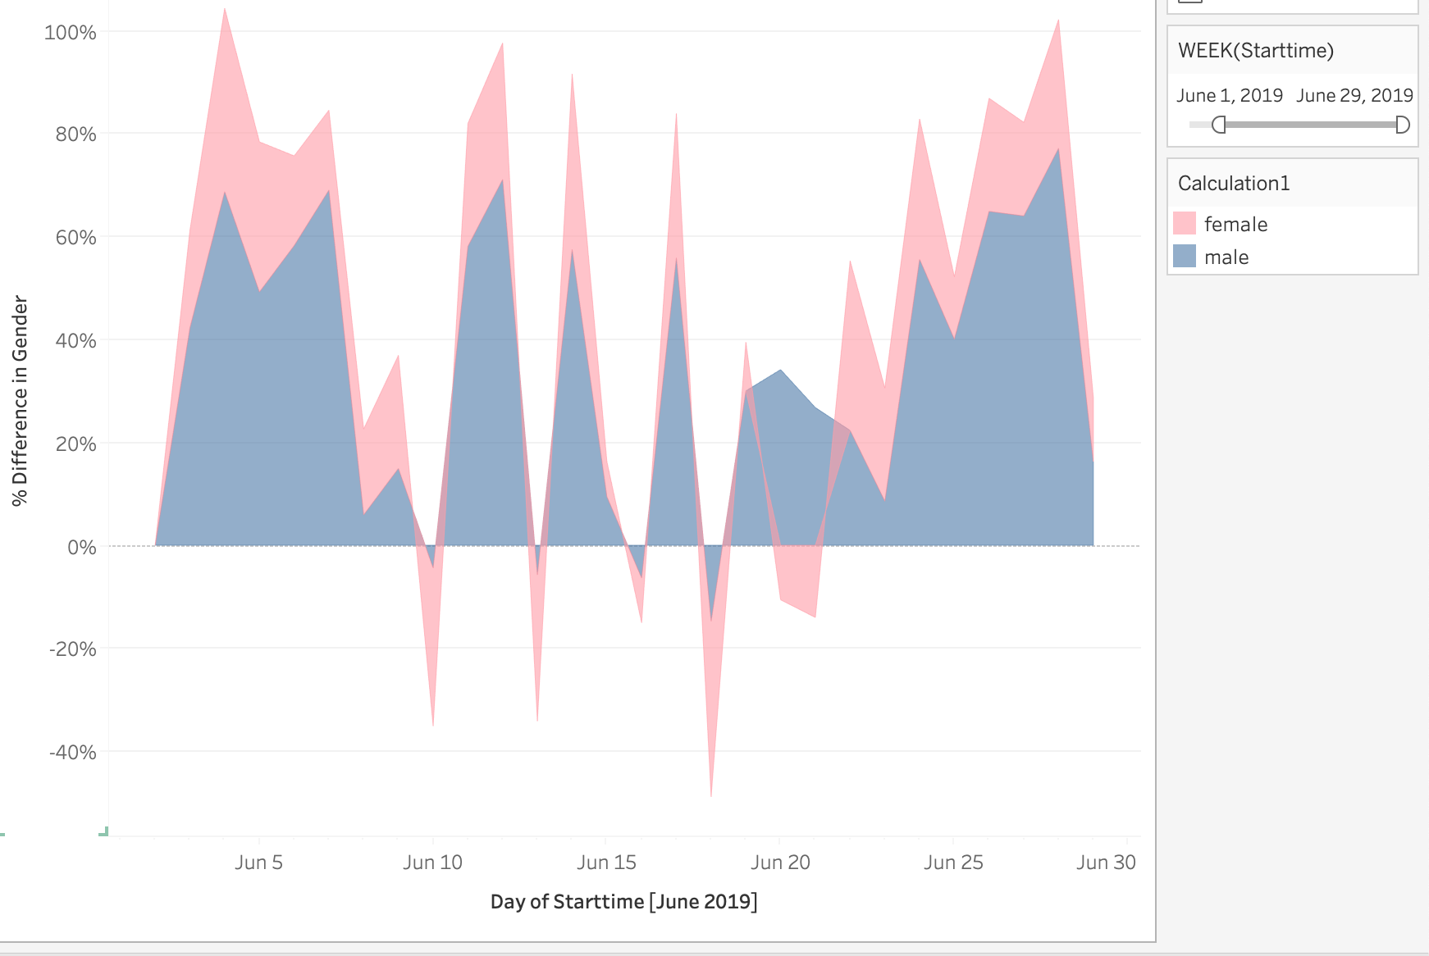

12. How does the average trip duration change by age (June 2019)?

**Trip Duration by age is highly correlated by youthful age.**

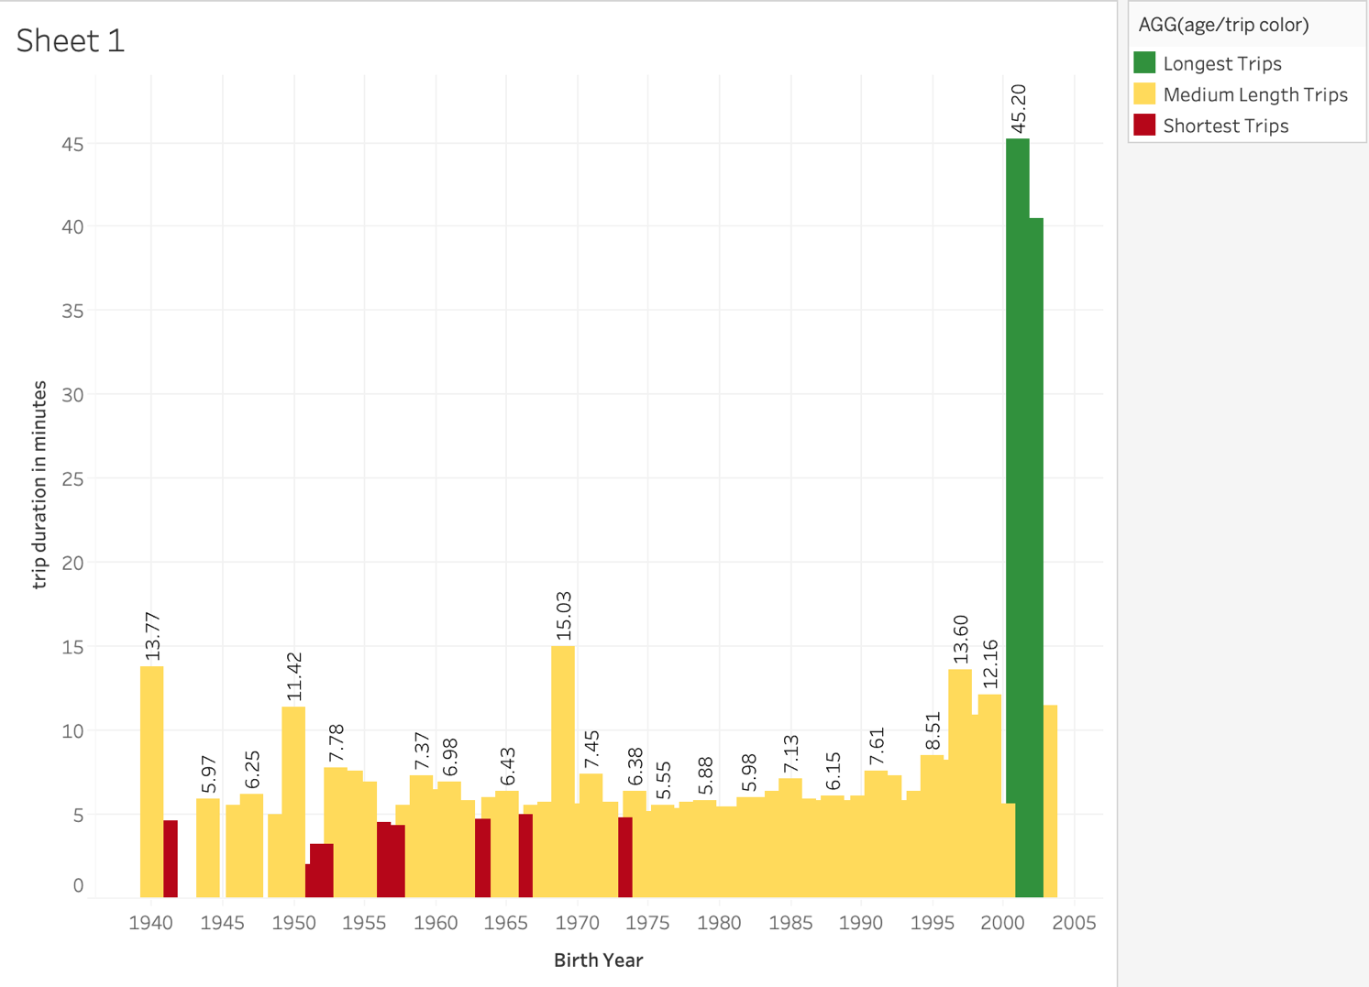

13. What is the average distance in miles that a bike is ridden?

In a new calculated field, we take total miles to date divided by total trips take:

**Average miles per trip = .5611 miles**

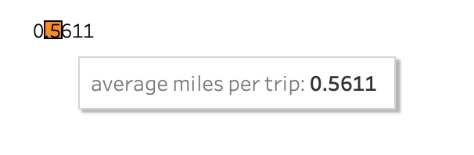

14. Which bikes (by ID) are most likely due for repair or inspection in the timespan (June 2019)?

**Filtered out Bicycles with the greatest amount of Trip Duration Time**

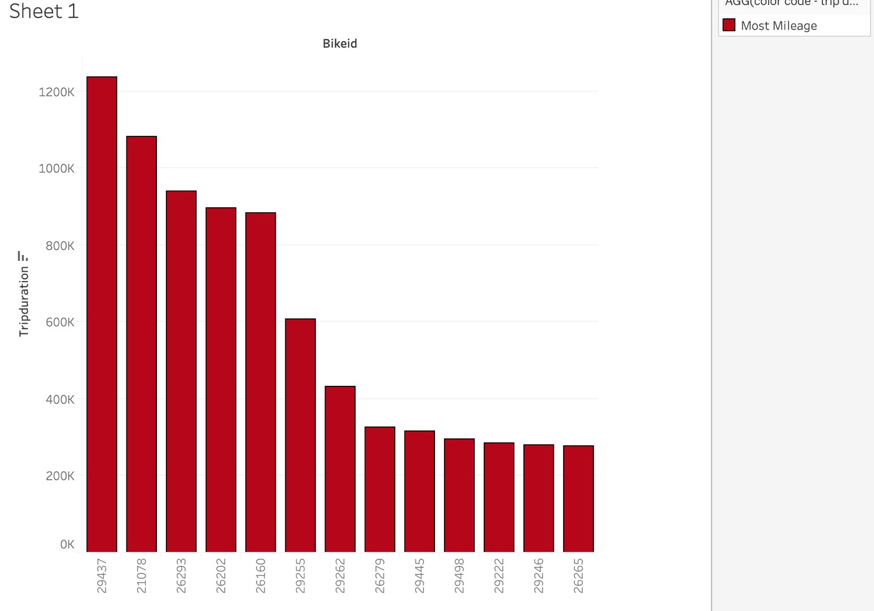

**Additionally, city officials would like to see the following visualizations:**

15. A static map that plots all bike stations with a visual indication of the most popular locations to start and end a journey with zip code data overlaid on top.

(as shown in 6 and 7 above, the most popular Start and End Stations are the same)

In this case, the data is from June 2019

**Busiest Stations are RED**

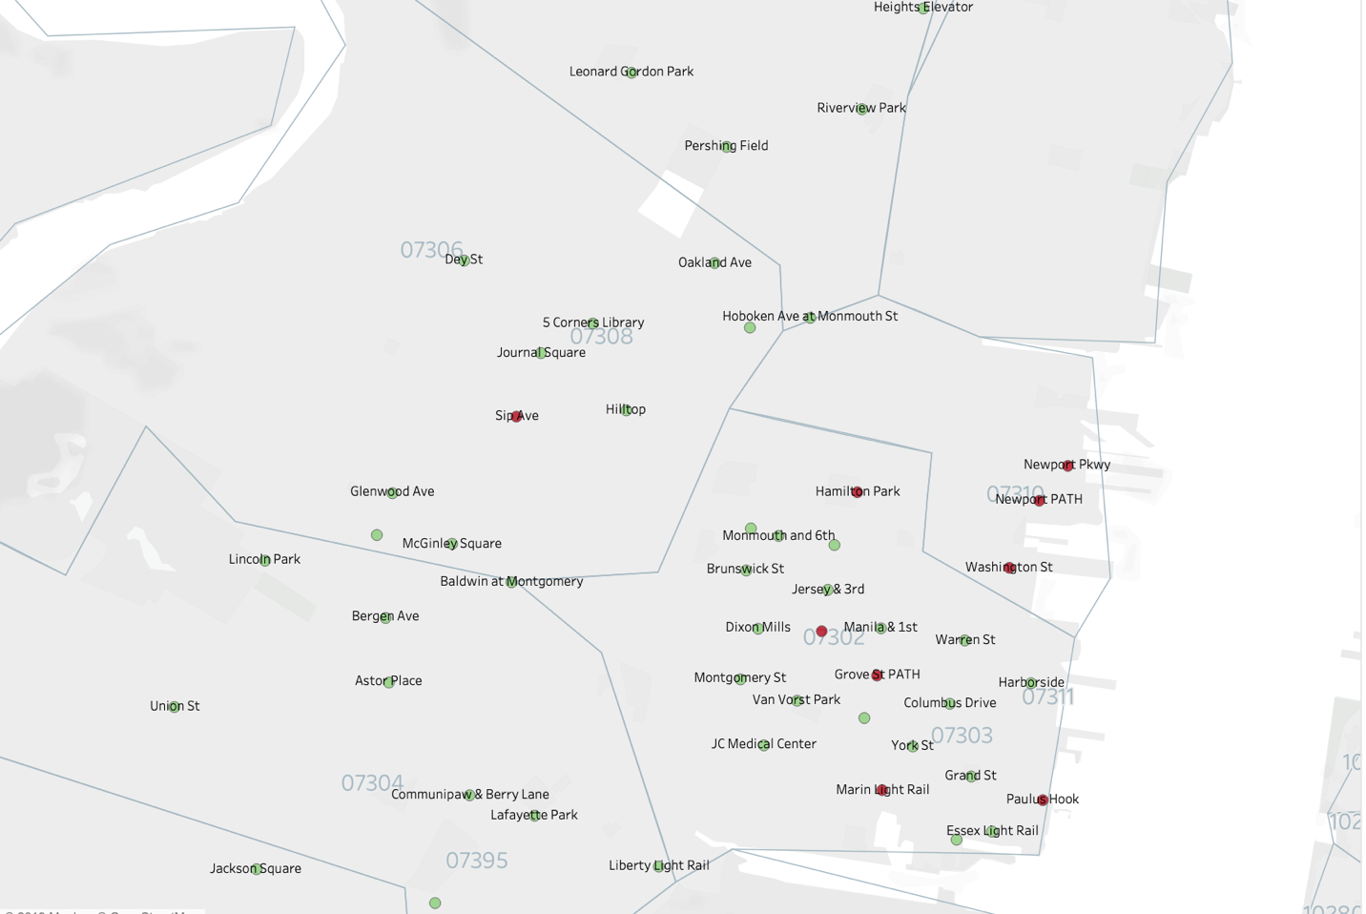

16. If you're working with a merged dataset: a dynamic map that shows how each station's popularity changes over time (by month and year) -- with commentary pointing to any interesting events that may be behind these phenomena.

Summer 2018 Data : June , July

The Biggest Percentage Losses occur in the middle of the island and in a cluster of concentration on the east side.

**The loss in the Middle of the Island might be explained by school ending, whereas the change by the waterfront on the east side is harder to interpret given the data at hand, but it is interesting to note that the losses are all in the same zip code in the east part of the city.**

